Author Keynote Speaker Keith Duncan. USA based CreatorKeith.com NGO INC , soon registered as PMinc (above). Cost of Extra Training Material is at Copy COST.

(NOTE: No copyright restrictions to duplicate using any method as these fundamental education services MUST be put into hands and minds of our forsaken people).
(c)copyright (™)TradeMark of BuiltBykeith.com World Evangelist Keynote Speaker Crusader Apostles of CEOSpace.net seen on SolutionManifesto.com and YouTube.com search ‘BuiltByKeith’.
Our primary promoter sponsors are Atty Jose Malvar Villegas office (632) 633-6697 and Dr. Morodo (Operational Economic Chief).

Publish Date: Thursday, August 8, 2019. Rev 1.0 (first draft) eBook.

Community Crime Watch Training Seminar Curriculum.

Community Crime Watch Training Seminar Curriculum. 2
OVERVIEW: 5 min. 2
DETAILS: 5 min. 2
FOIA.ONE Open Public Database. 5 min. 4
UNIocracy.ORG is the Perfect Utopia self regulating checks and balances. 5 min. 5
Training OVERVIEW: 10min 6
DESCRIPTION of PURPOSE 15 min. 6
START OF Anti Crime Workshop. 15 min. 8
PART 1. Open discussion in room on prime topic of 8
PART 2. Break into GROUP discussion. 30 min. 8
BIG GROUP: Discussion overview of small group leader summary. 30 Min. 8
ROLE PLAYING. CROOK versus Guardian / Watch Tower. 20 min. 9
CONTINUE DOCUMENT HERE. 1 hour 11

Community Crime Watch Training Seminar Curriculum.

Creating train the trainer curriculum, published PDF and VIDEO on line.
Website of your domain choosing included in price. client3635.wix.com/CCW being created now.
Expanded groups are hereby granted full permission to COPY, Duplicate, and extend these master teaching materials for their own customized use depending on their exact needs + purposes.
Includes 1 starting Demonstration professional VIDEO posted on youtube.com and Linked to above website. We train all others to use the power of VIDEO to ensure the safety of all citizens.

Initial 4 training sessions of 4 hours each session Posted on CCWph.com

Includes downloadable Electronic PDFs, Videos embedded and cross linked youtube.com channel
CROSS endorsement (FREE) on SolutionHousing.ORG/Endorsements now.

Our required Company Profiles are located top of client3635.wix.com/BidOnkeith as in year 2011 our charge for executive level consultants was legally binding contract $10,000 USD for one day once we agreed on the issue problem and brought our resources to the table to show them HOW to solve any problem with SolutionPeace.com/5steps method for any micro to MACRO issue.

OVERVIEW: 5 min.
Based on our Aug 7 + 8, 2019 historical legacy meetings with Attorney Jose Villegas, these simple step by step methods outlined below create our new world communities free of almost all crime.

CCWph.COM (soon launched). client3635.WIX.com/CCW will soon be a standard for securing any community or land area with Open Circuit TV/microphones/Speakers over free wifi to all SCHOOLS and Barangay hall, public areas, all direct funded by WorldSchoolFund.com

Your CCW foundation fame and fortunes will increase dramatically once all corporations, community leaders, and Government officials endorse our simple world saving solutions for this expanding Livelihood Train the TRAINERS.
We bring CEOSPACE.NET top executives here soon. Bob Proctor, Les/John Brown, Dr. David Gruder (Integrity professor), Keith Duncan (#1 Anti Crime Expert) are our top world marketing experts led by Berny Dohrman. These top executives are showcased on top of SolutionManifesto.com the ultimate UTOPIA of EARTH.

DETAILS: 5 min.
Basis is fast path community watch methodology to secure safety of neighborhood using checkpoints, photos, and video interview techniques to confirm reasons for anyone visiting an area.

These simple direct methods must be non confrontational yet psychology use to repeal those who are scammers, con artists, or crooks who are scooping out new victim targets, store and forward techniques that use Super FACEBOOK FOIA.one at local level that will expand to one Intl database coordinated with local police and even military.

This includes direct coordination agreements and forward of potential crime evidence to PNP, NBI, MILITARY, DOJ, and other law enforcement agencies who deal with investigation and arrests procedures. We already have direct connections to each of these prime top leaders with decision making authority for past 4 years as that is what we DO almost every day. Supply the most simple and incredible reality of use of common sense, existing technology, and wisdom bible principles of universal Integrity.

Key is electronic distribution of training material over website snd facebook media so everything is online. Inviting Media journalists to attend and viral social media of websites, Youtube Channel, and Facebook Pages is easily used to get event publicity. NOW new trained community watch spokespersons can communicate directly with residents and business owners on how to secure their neighborhoods and businesses to prepare for billions of real $$$ assets transferred to ASIA with trademark copyrighted(soon patented) EVOTE.ONE FOIA.ONE single universal secure open public database.

Focus is always on security using available resources of cell phones, resident lookup database of who lives where, visitor logbook online, body cams, and especially Walkie talkies.
This are the Base for this Proposed, historical MOA.

Formally Submitted,
CEO Keith Duncan

FOIA.ONE Open Public Database. 5 min.

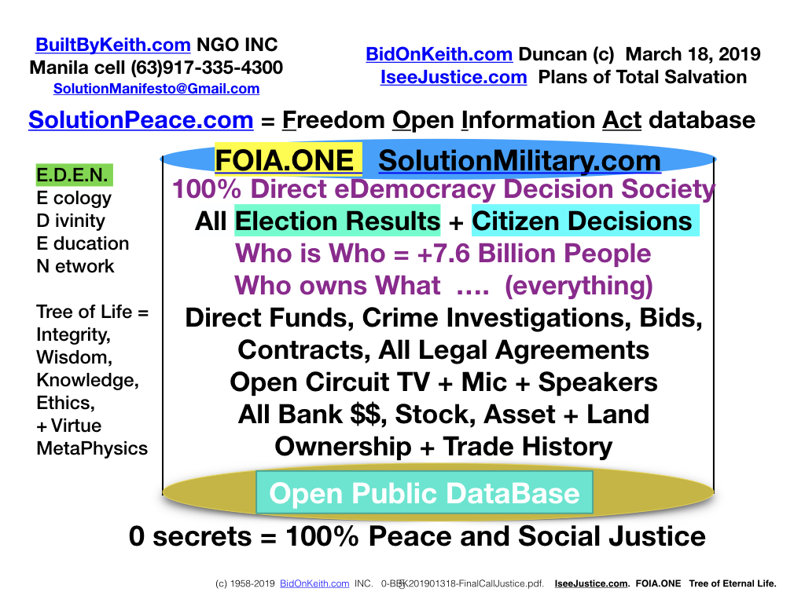
This is the FOIA.ONE that unifies all mankind. It contains all the base human knowledge and wisdom and URL links to all other databases in all nations.
This new world FOIA.ONE that prevents almost all crimes with simple use of Technology, common sense, and Integrity. This will be WORLD FAMOUS once our world leaders see these are the ONLY answers to UNIFY reform our own people...
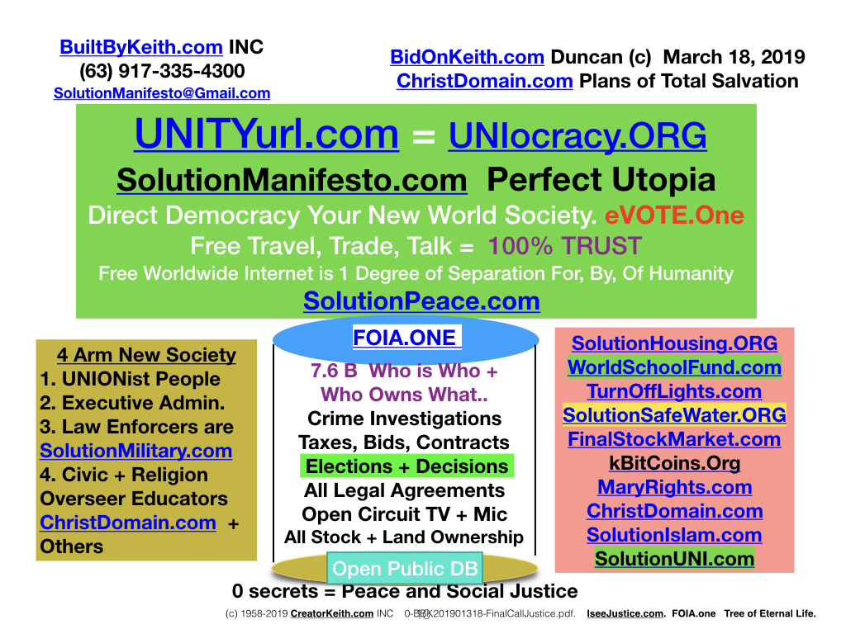
No more 15 Dynasty families draining 70% of the Philippine PROFIT GNP annually.

UNIocracy.ORG is the Perfect Utopia self regulating checks and balances. 5 min.

This is the true answer for all humanity. Our world is now Free trade travel, education, and opportunity for all our young adults that eliminates all the ‘white hair’ mega family dynasties.

Training OVERVIEW: 10min

The Benefits and value of this ‘Train the Trainer’ series is absolute and profitable for all communities.

Those who use our training will be called GUARDIANS and ‘WATCH Towers’ for that is what is required to identify and repel away all undesirable persons who can not show WHO they are visiting and reasons for their appearance. The low and high level crime persons are well verse trained to ‘CON’ their victims with well rehearsed answers to falsely justify their entry into our secured communities. This interactive workshop includes ROLE PLAYING to learn the safe language to repel away these crime invaders. Most send scouts to find the ASSETS and OTHERS to come and steal our wealth during the black night. This is the ARTFUL DODGER book from London in 1800’s.

DESCRIPTION of PURPOSE 15 min.

Our world security concerns at all levels have always been jeopardized and comprised by ‘SMART’ crooks and well spoken criminal enterprises. They see the weaknesses in our community perimeters and infiltrate using con-artist talk when confronted. This GUARDIAN training teaches our barangay captains and guardians how to safely confront any unknown person and deny them access to our assets and families by asking the correct ‘rehearsed’ questions.

Our prime answer solution is to train our guards and public to use hand held smart phones, walkie talkees, and if possible direct connection to Hi Speed WIFI for instant relay of critical video and photos to our Barangay Captains, to our local PNP post, and other members of our guardian groups. Once all crooks know and experience they are being recorded, they will flee as these become the universal standard of repelling unwanted persons. This includes drug dealers, prostitutes, common thieves, pick pockets, and others who prey on our young, teenagers, elderly, women, and even our men. For our Men can easily be bribed with gin, card game offers, prostitution offers, sale of counterfeit goods. Think: ’OH IT’s GENUINE ROLEX or Apple Iphone’ (meaning it was just pickpocketed or stolen from nearby home). This is called FENCING and is a prime crime issue involving Pawn shops for quick cash of stolen goods.
The language and actions we teach you are how to be safe by asking the RIGHT questions to put the focus on the new person. Part of this training is ROLE PLAYING as we all learn the correct words to ask and how to ‘COUNTER’ any objections with MORE QUESTIONS. This is to clarify the person is honest and legally authorized to pass each checkpoint. With our existing communication technology it is so easy to call ahead to the next checkpoint and to notify the person they claim they are visiting.

Each of these simple techniques is standard procedures in other nations. Our CCW leaders say that FEW operational procedures are taught by our own PNP, DILG, and LGU groups. WHY? Issue has always been funding. Consider the cost of CRIME at point of commission. If the culprit crook is EVER identified, it is near impossible to FIND THEM and bring them to justice with the total lack of technology that is denied by our government to our POLICE, our Investigators, our Prosecutors, our District Attorneys, the Judges, and our new PhilippineJury.com system.

START OF Anti Crime Workshop. 15 min.

PART 1. Open discussion in room on prime topic of

- WHAT ARE THE WORST CRIMES in our communities?
- What level of support do you get from Law Enforcement? NBI, PNP, Military, other.

PART 2. Break into GROUP discussion. 30 min.

Break into groups of 4 persons. Answer these questions on paper.
- What is your communities prime crime?
- What are current methods to PREVENT these crimes?
- Who are the authorities responsible for security?
- What are YOUR best methods to stop the worst crimes?
- If you had the authority, resources (money), and time, what exactly would YOU do to secure your communities?

BIG GROUP: Discussion overview of small group leader summary. 30 Min.

ROLE PLAYING. CROOK versus Guardian / Watch Tower. 20 min.

Now we start the interactive role playing of this critical workshop. Two people are given role playing scripts that are typical interactions between Guardian and 1. HONEST PERSON. 2. CRIMINAL INTENT PERSON.

The goal is to learn the languages of being polite yet CHALLENGING the person to validate they ARE WHO THEY SAY THEY ARE...

The Check points (also known as Watch Towers) are strategically located at entrances to each community or business park.

KEY NOTE DIFFERENCE (pure Psychology put into Best Practice)
- Most people are honest and will answer your challenge answers to your satisfaction to gain authorized entry.
- ALL CRIMINALS are SKILLED con-artist LIARS who will say ANYTHING to by-pass these checkpoint challenges. The language of our system is to create barriers and delays to discourage ANYONE who has ill intent from entering our protected communities.

ONE prime method to challenge a person is keep asking the NEXT BEST QUESTION of
- WHO are you.
- Please sign your name in our log book. Best method is electronic entry on your cell phone transmitted to Barangay Captain or office. Add description of the person of Height, age, color of clothes and description of anything they are carrying or riding. (Motorcycle, bicycle, boxes, etc).
- Please provide (and leave) your ID. Based on your assessment, they can be granted free access, or given a numbered badge colored Green, Yellow, or Blue depending on their potential security risk.
- What is phone number and address of the person you are visiting.
- Who else in our community knows you and can testify WHO you are.
- (fill in your best challenge questions here) ________________________
- _____________________________________________________________

It is LEGAL to LIE to the criminal. For any criminal WILL PROFESSIONALLY LIE to YOU as they have EVERYTHING to steal/gain, and YOU have everything to LOSE....
Lying is NEVER an issue if you feel your safety is being threatened. Example: tell the person they have already been face scanned by remote camera and the Barangay Captain and neighborhood has already been electronically notified.
You can even ‘FALSE’ speak into your Walkie Talkie or Cell phone to convince the person to RUN AWAY. With Practice, this become an natural respond to a perceived and often real threat.

PRACTICE, PRACTICE, PRACTICE this key exercise until you have the questions and objection handling memorized.

Anyone who is HONEST will answer ANY question you pose to your satisfaction. Anyone who DIVERTS away from a direct answer of YES or NO must be asked the NEXT prime question to validate their visit purpose. When you THINK like a crook, you can SEE who are the real crooks. remember: THEY LIE about ANYTHING to gain entry to your domain..... ChristDomain.com is also key cornerstone of EDUCATION with unification Outreach Ministries by ALL religious groups who retain their own theology but SHARE common worship centers and educational programs that benefit EVERYONE at one time.
See world changing SolutionPeace.com/5steps that solves ANY micro to MACRO problem anywhere in universe.... Basis for ALL ministries of Social Peace and total world justice. keith.

USE of SIGNS warning about Open Circuit TV and AutoMatic Face Recognition. These are easily posted (laminate in plastic) and are most effective in visually repelling unwanted crooks.
Listing requirements for authorized entry also eliminates the need to ask challenge questions above.

Once these become standard practice for communities, POLICE, even MILITARY, no crook will dare enter any protected community because of the power of FOIA.ONE that arrives as soon as PRESS CONFERENCES by World Leaders finally occurs. Keith Duncan.

CONTINUE DOCUMENT HERE. 1 hour

